Welcome to The Netherlands!

As all is well you have seen this, aready:
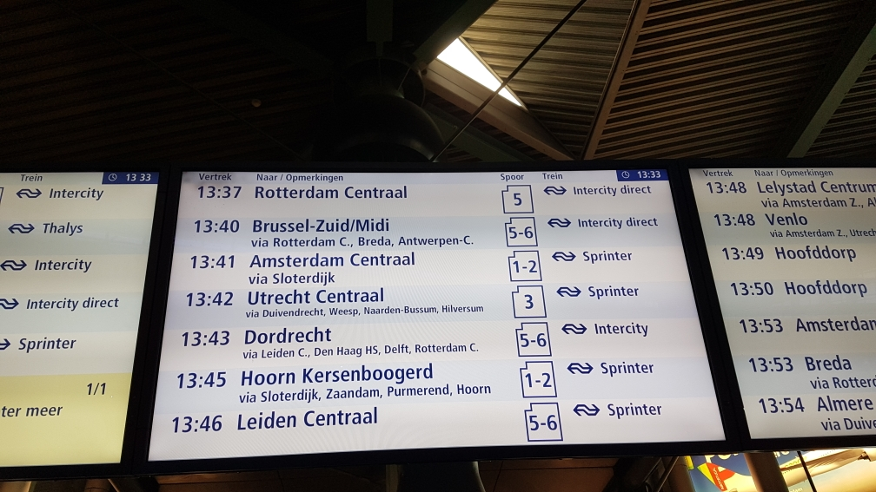
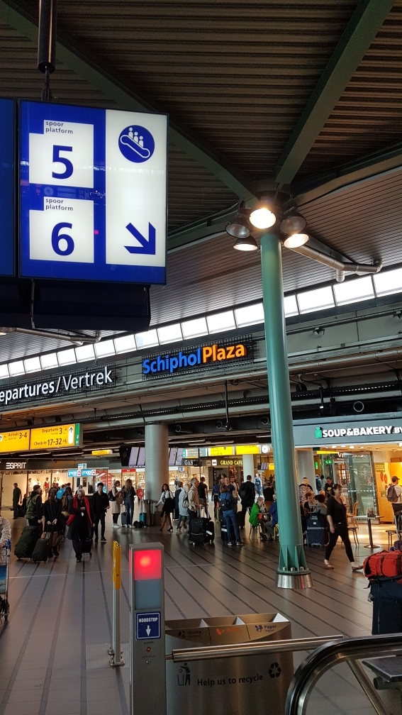
Take the train to Dordrecht, get out at Rotterdam-Blaak.

Check in here!
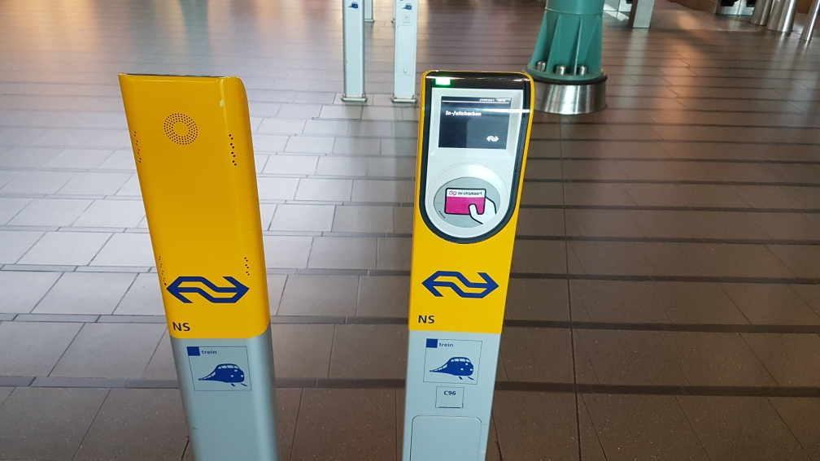
Now you are here:

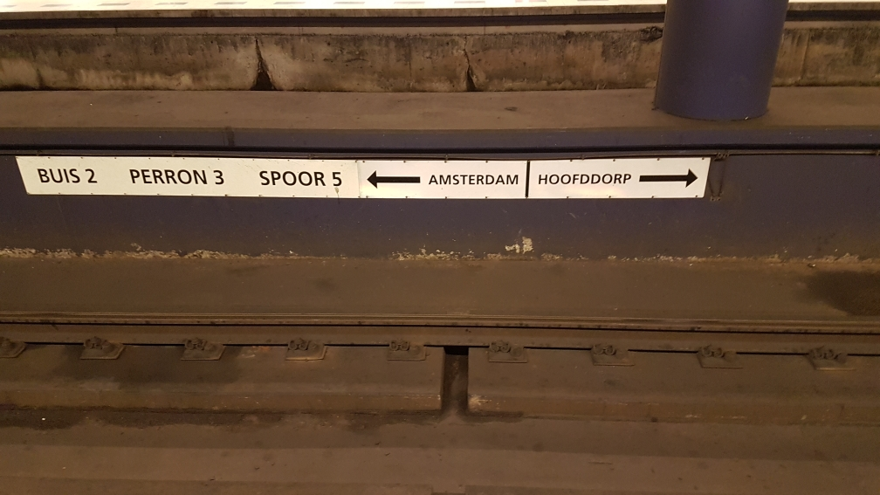

Question 1:
Amsterdam is to the: A North B East C South D West

When you come out of the tunnel you will see this at the right side:

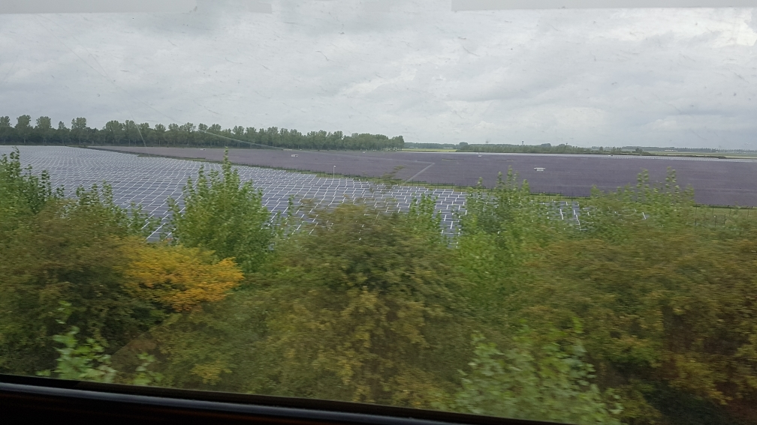
Question 2:
What would you have seen here 400 years ago?
…………………………………………………………………………………………..
On the left and right side you will see this kind of landscape:

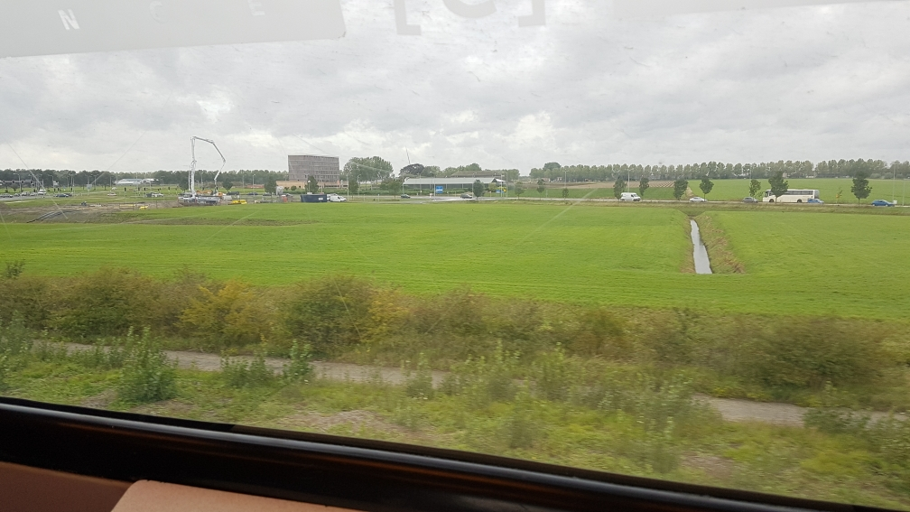
Question 3:
What kind of soil is this?
On the left you see this train track:
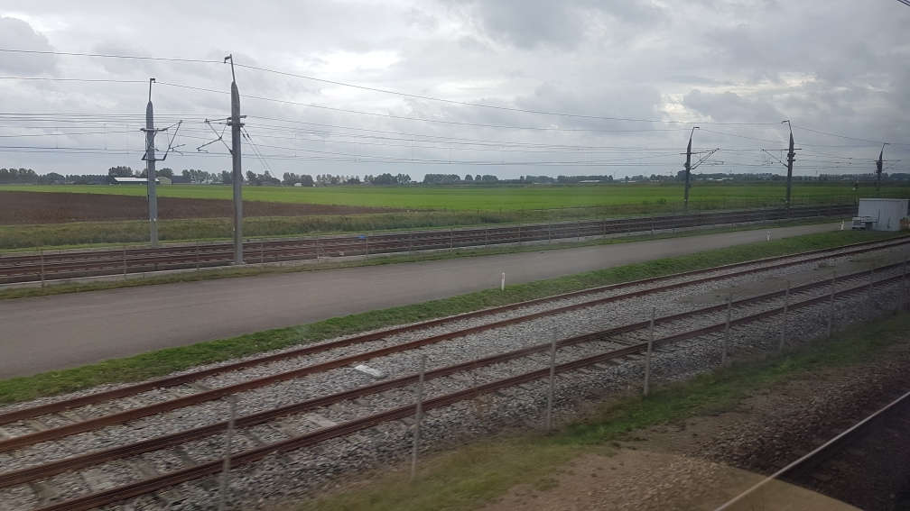
Question 4:
What is the final destination of trains using this track?

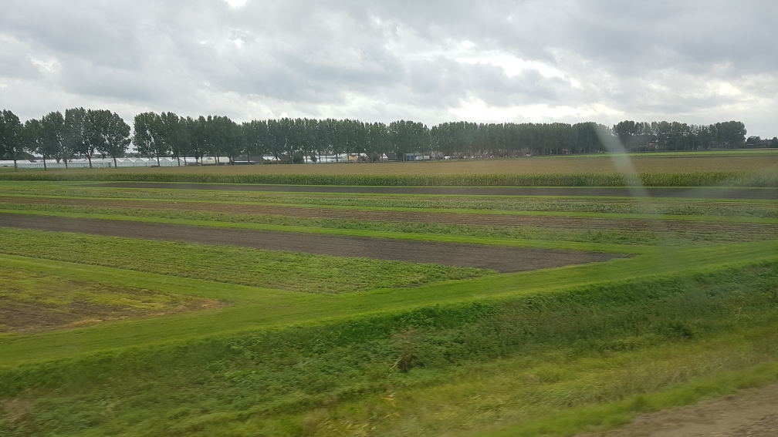
Question 5:
What kind of farmer uses these grounds?
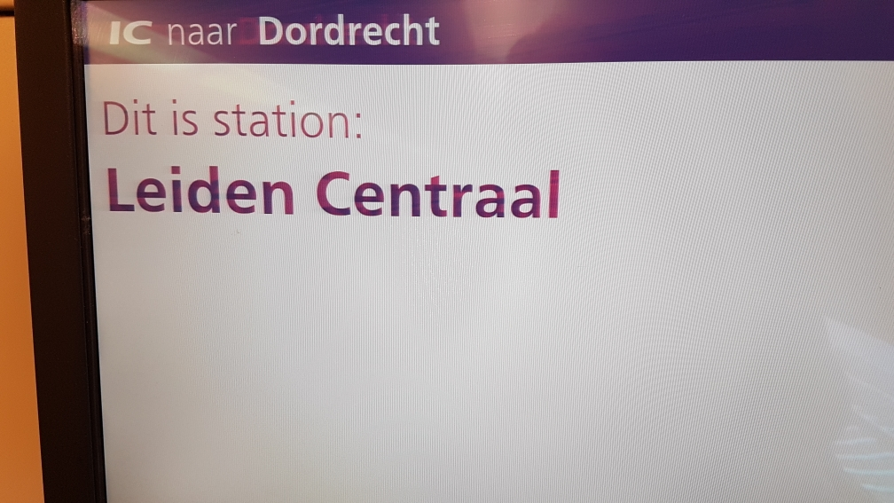
Question 6:
You are now in Leiden.
Leiden has the oldest …………. Of The Netherlands. ( kind of education institute)
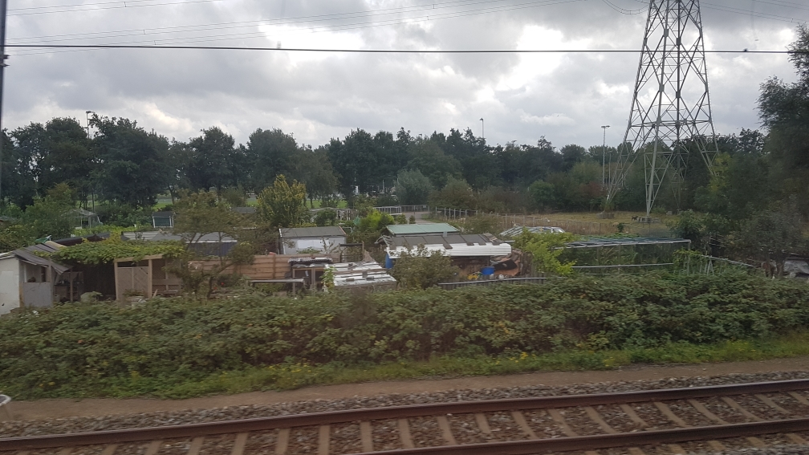
Just outside of Leiden you see this.
Question 7:
What are you seeing here? (Left side of the train)
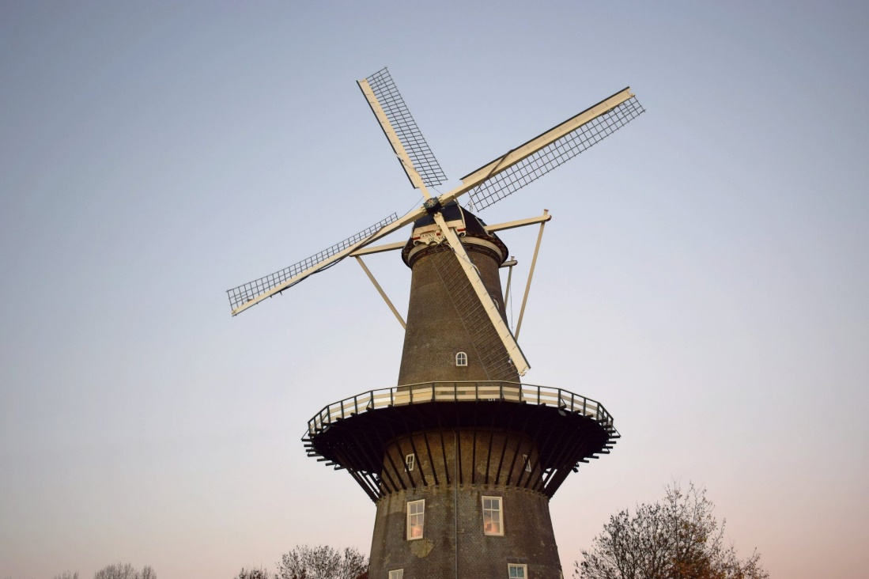
On both sith of the rail track you see windmills, like this one.
Question 8:
Mention 5 purposes a windmill can have.
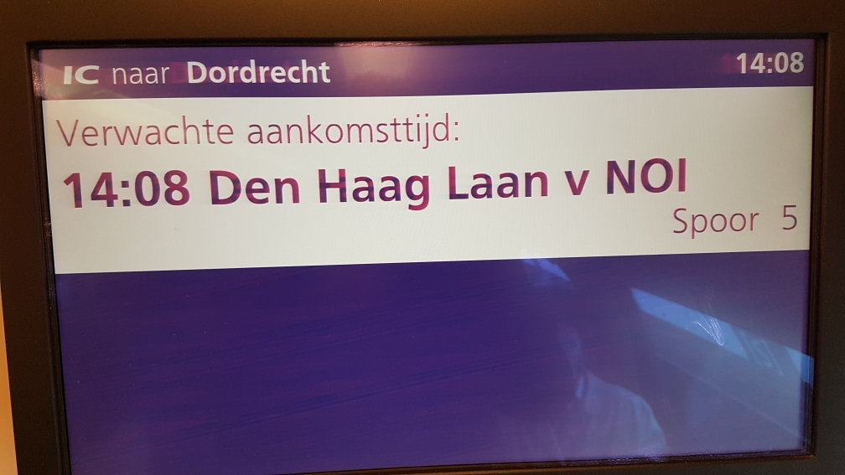
You have now reached this station.
Question 9:
To which continent does this train station refer to?

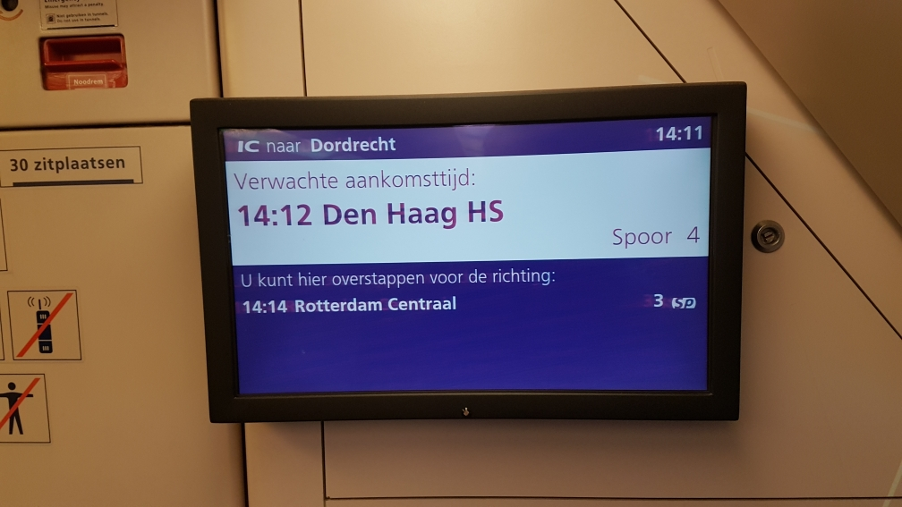
You are now in this station: Den Haag Hollands Spoor, a central station.
Question 10.
The Hague has 2 central stations. How is that possible? Explain your answer.

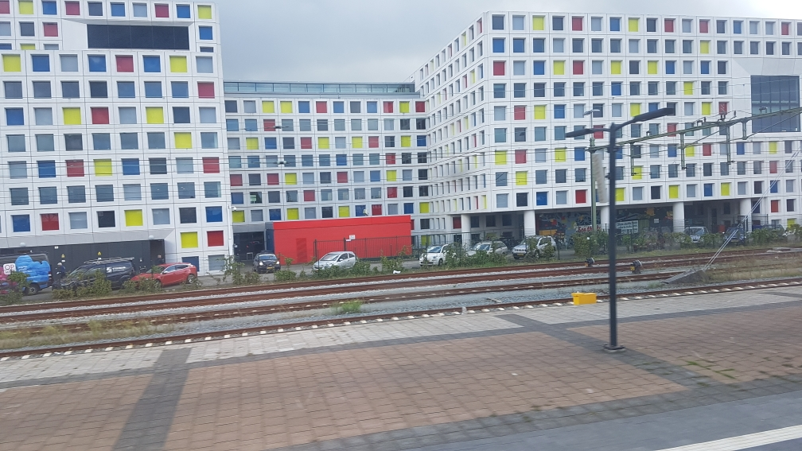
Just out side The Hague Hollands Spoor (left) you will see this building.
Question 11:
What is it: A a prison B a school C department of Finance D a paint factory
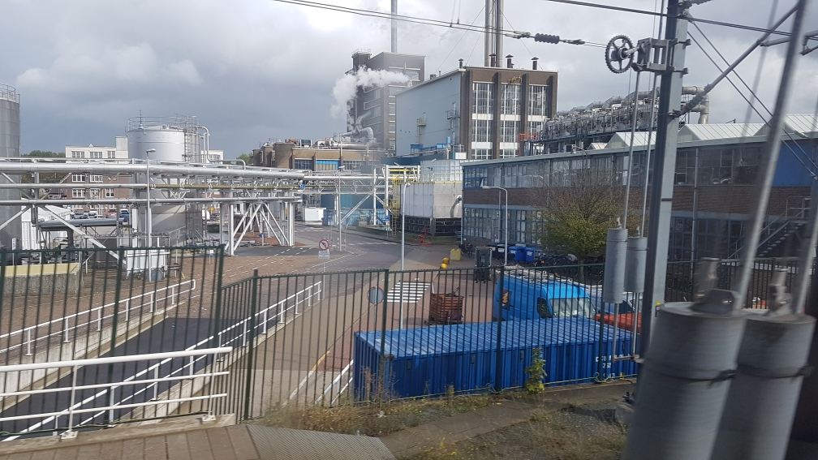
Just before coming into Delft you see this factory.
Question 12:
Mention one of the products of this factory.
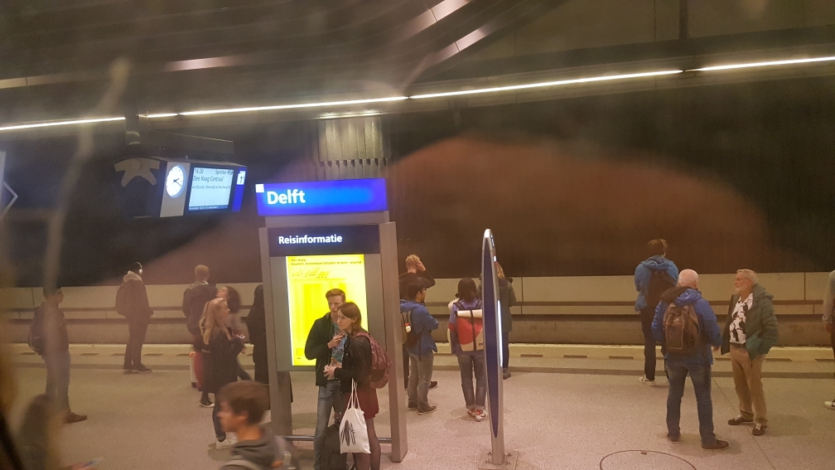
Now you have reached Delft station.
Question 13:
Why are 8000 Chinese people living in Delft?
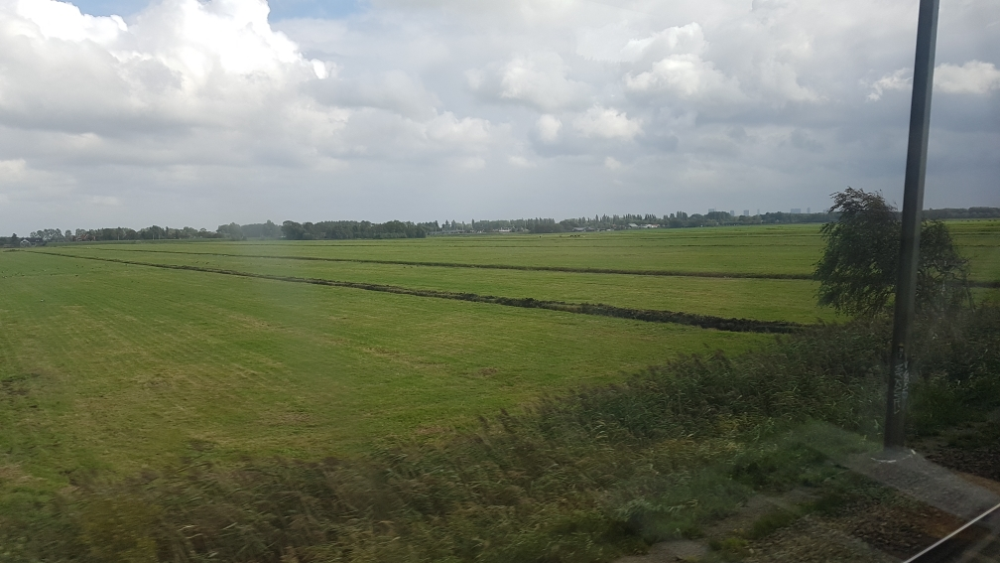

Between Delft and Schiedam you will see this kind of landscape.
Question 14:
What kind of animals feed on this grounds in spring, summer and early autumn?

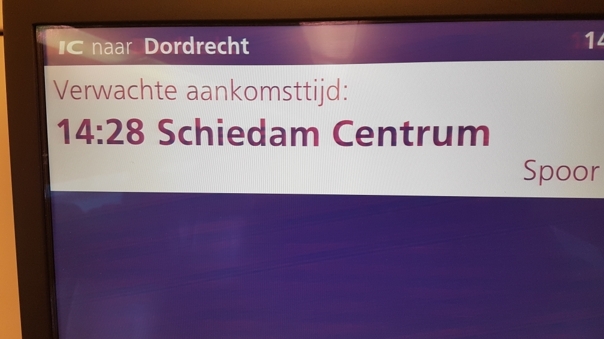
Yeah you are in Schiedam!
Question 15:
What is the most famous local product of Schiedam?

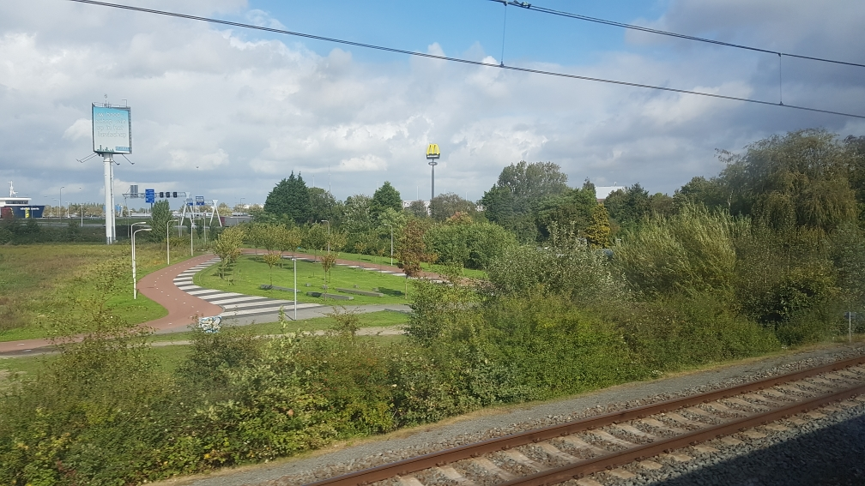
Just out side Schiedam Centrum you see this yellow sign at the left.
Question 16:
What is the price of a regular hamburger?
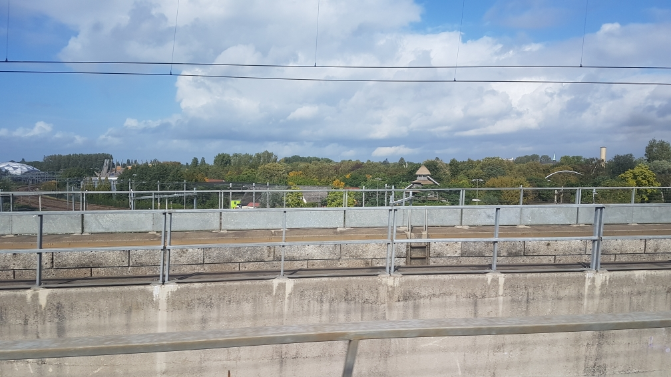
Question 17:
What do you see at the left side, behind the rail track?

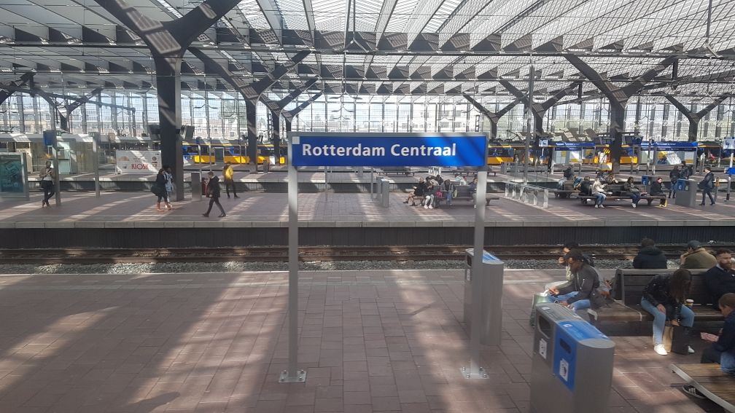
You have now almost reached your final destination: you are at Rotterdam central.
Question 18: What do you see in the roof of this station?
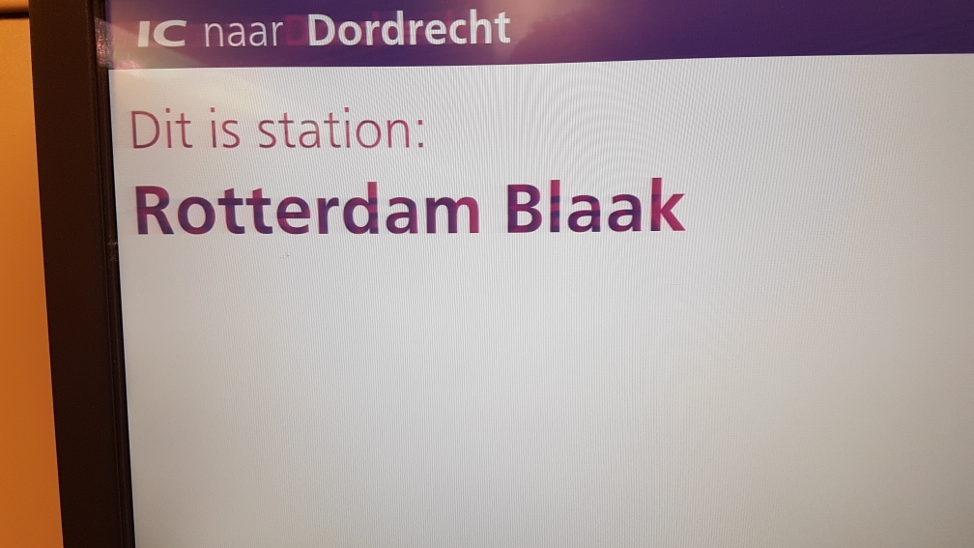

Hurry up, you have to get out! Check out with your ticket and go up!
Before you go up answer the last question:
Question 19: When you get out of the station what will you see at the left side?
A a police station B stupid houses C a large garden D a boat
Now you have answered all the questions. When you are upstairs you are not allowed to write anymore. Hand your paper in to mr.Bogaard.

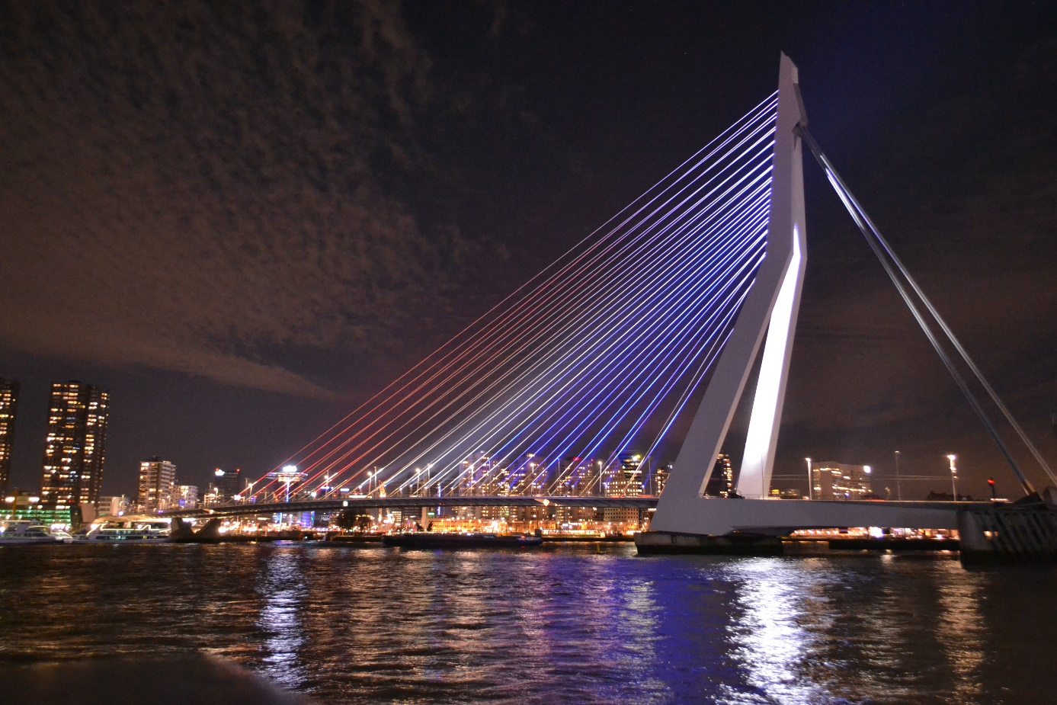

All students and teachers of Comenius College wish you a pleasant stay in
The Netherlands !!!

