SOIL EROSION
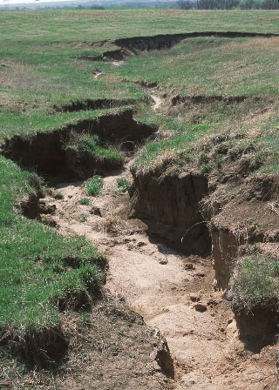

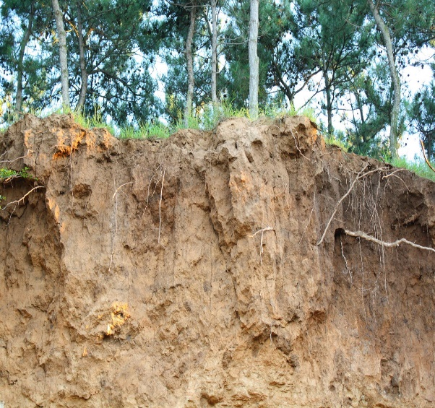
Soil erosion is the displacement of the upper layer of soil, one form of soil degradation. This natural process is caused by the dynamic activity of erosive factors, that are, water, ice (glaciers), snow, air (wind), plants, animals, and humans.
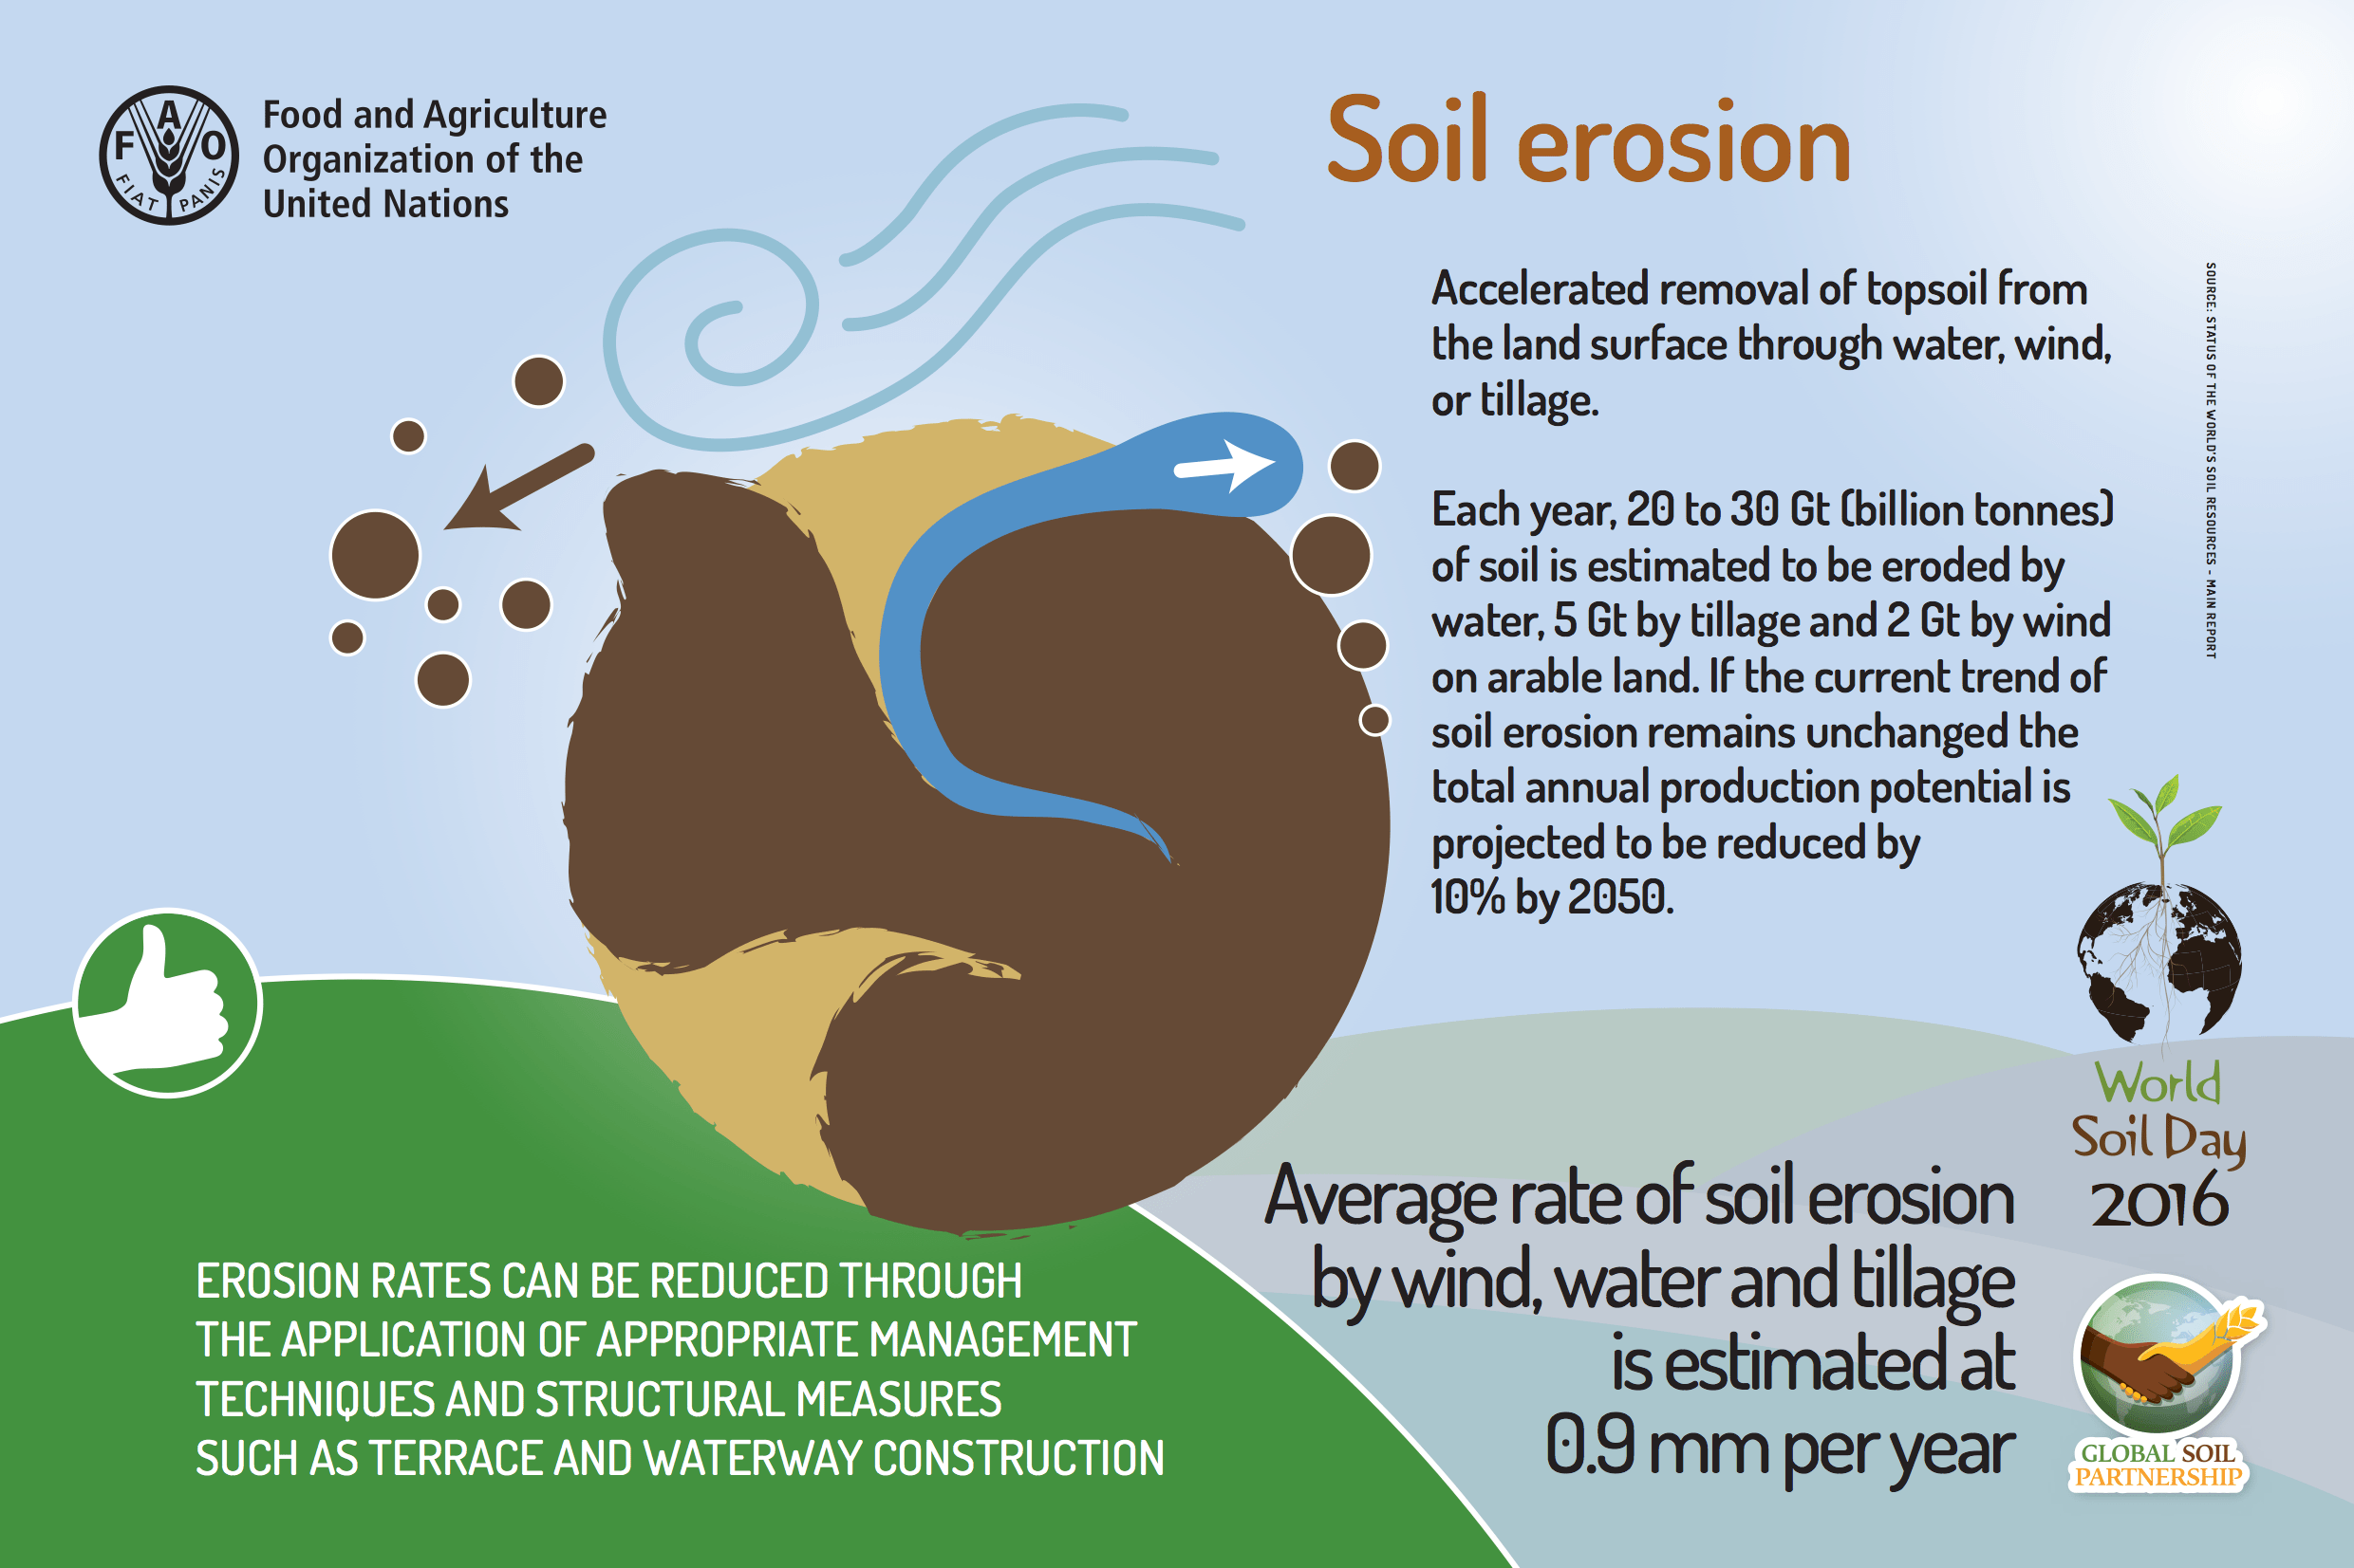
It is among the exsogenic surface processes, because unlike endogenous (e.g. volcanic eruptions) it lowers the Earth's surface. Even if erosion is often done by weathering, this concept should be distinguished, since the weathering means the decomposition of the rocks and the formation of soils, and the erosion means draining the soil.

Erosion is an important natural process, but nowadays it is often increased due to human activity which is harmful; since it is most often caused by deforestation, overgrazing and construction of traffic routes. We are trying to reduce the problem of erosion by afforestation. A certain level of erosion is natural and important for a healthy ecosystem. For example, gravel is constantly moving through water flows. However, if the removal of gravel is too large, there may be problems such as landslides, the pollution of clean water with sediments and the consequent reduction of water quality and soil fertility.
FACTORS (on surface):
- Surface predisposition,
- soil structure,
- precipitation,
- surface overload with plants, rocks etc.
Erosion would displace more soil if the soil was more prone or if there was a lot of precipitation or if the earth is sandy or sludgy. Vegetation on the surface is the most important and variable factor, because with its underground roots it strongly binds the floor. When the fire or construction of the road or the reduction of forests destroys vegetation, the possibility of material removal increases.
One of the most extensive erosion is happening in China in the Yellow River and the river Yangtze. The Yellow River wash away each year into the sea over 1.6 billion tons of sediments.
Modern agricultural techniques are the largest factor in contributing to the global increase in erosion levels. The cultivation of agricultural land that breaks down the soil in finer pieces is one of the primary factors.
The problem is that we started to use equipment which allows deep plowing. Because of this, the soil is milder and the structure becomes like sand, which leaves water through and makes it more accessible to erosion.
In an undisturbed forest, the mineral soil is protected by a layer of leaf litter and a humus that cover the forest floor. These two layers form a protective layer above the ground that absorbs the impact of the drops of rain. They are porous and permeate rainfall and allow rainwater to slowly percolate through the ground below, instead of falling to the ground at full speed and thus cause faster soil degradation.

https://en.wikipedia.org/wiki/Erosion
https://www.soils.org/news
https://www.nationalgeographic.org/encyclopedia/erosion/

