Soil Pollution
Healthy soils are the foundation for food, fuel, fibre and even medicine. Soils are also essential to our ecosystems, playing a key role in the carbon cycle, storing and filtering water, and improving resilience to floods and droughts. And yet we are not paying enough attention to this important part of our planet.
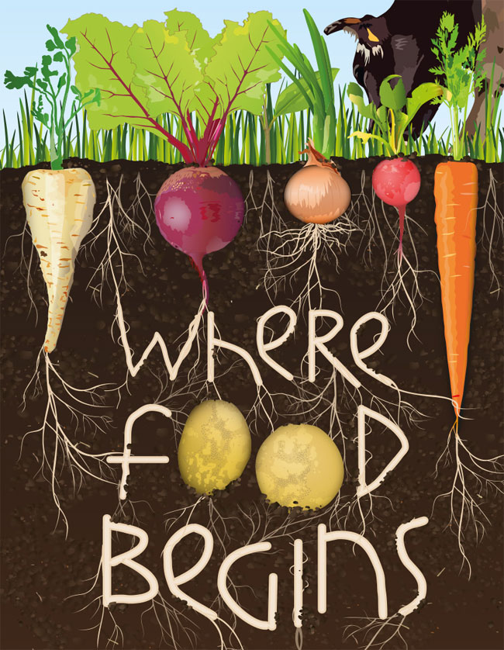
Unfortunately, 33 per cent of our global soil resources are under degradation and human pressures on soils are reaching critical limits, reducing and sometimes eliminating essential soil functions.
95% of our food comes from our soil
It can take up to 1,000 years to form one centimetre of soil, and with 33 per cent of all global soil resources degraded even longer.
Soil - a “nearly forgotten resource”
Soil is also the largest pool of organic carbon, which is essential for mitigating and adapting to climate change. At least a quarter of the world’s biodiversity lives underground, where, for example, the earthworm is a giant alongside tiny organisms such as bacteria and fungi. Better management can assure that those usually unnoticed organisms boost soil’s ability to absorb carbon and mitigate desertification.
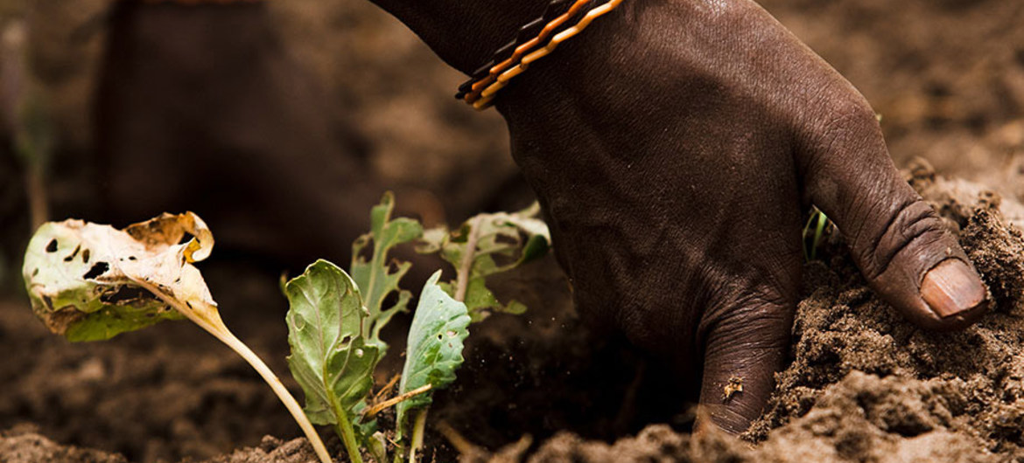
Aleksander Koželj

https://news.un.org/en/story/2014/12/485462-spotlighting-humanitys-silent-ally-un-launches-2015-international-year-soils

