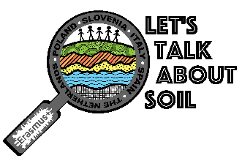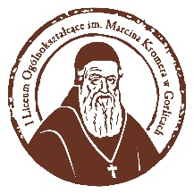

SET OF RULES FOR THE COMPUTER GRAPHICS COMPETITION
SAVE SOIL
- The competition is part of ‘Let’s TalkAbout Soil’ project and it’s addressed to all students of partner schools.
- The coordinator of the competition is Mr Jure Radisek.
- All the works created for the competition should follow the idea of saving soil: ‘SOIL POLLUTION – SAVE SOIL’.
- All the works submitted for the competition must obey copyright laws.
- Original photos, drawings and slogans in English can be used.
- Any legal computer software can be used to create the works.
- Students can work individually or in teams of two.
- Every student / team can submit one work.
- Every work must be signed with the name and country of the competitor.
- Every work submitted for the competition must be sent to the coordinator’s e-mail address, saved as jpg or pdf.
- The works must be submitted no later than 20th March 2018.
- The results of the competition will be given during student exchange in Tenerife (25-29.03.2018).
- A panel consisting of two representatives of each partner country (a teacher and a student) will decide on the results of the competition.
Polish coordinator
Marzena Wójtowicz

